Overview of Deep Learning-Based Approaches for Human Image Classification and Detection in Mass Crowds.
Yateesh Gutti^{1*}, Dr D.Vishnu Vardhan^{2*}, J Stalin Babu ^{3*}
^{*1}Assistant Professor, Department of Computer Science and Engineering, Koneru Lakshmaiah Education Foundation, Guntur(D), Andhra Pradesh, India
Email: yatesh424@gmail.com
²Department of Professor, Department of ECE, JNTUACEA, Anantapur, Andhra Pradesh, India
Email: vishnu.ece@jntua.ac.in
³Assistant Professor, Department of CSE, KLEF, Vijayawda, India
Email :stalinbabu.jalli@gmail.com

Abstract
The proliferation of deep learning has revolutionized human image classification and detection
in mass crowd scenarios, enabling applications such as crowd monitoring, public safety, and
behavioral analysis. This paper provides a comprehensive overview of recent deep learning-
based methods for detecting and classifying humans in dense crowd settings, focusing on
convolutional neural networks (CNNs), object detection frameworks like YOLO and Faster R-CNN, and advanced architectures incorporating attention mechanisms and spatio-temporal
analysis. We discuss key challenges, including occlusions, varying crowd densities, and real-
time processing requirements, while highlighting state-of-the-art approaches and their
performance metrics. Additionally, we propose a novel Density-Aware Attention Network
(DAAN) that improves detection accuracy in high-density crowds. The paper also addresses
ethical considerations, such as privacy and bias, and outlines future research directions.
Keywords: Deep Learning, Human Detection, Crowd Analysis, Object Detection, Convolutional Neural Networks, YOLO, Faster R-CNN, Attention Mechanisms, CrowdHuman Datase
Introduction
The ability to detect and classify humans in mass crowds is critical for applications like urban
surveillance, event management, and disaster response. Traditional computer vision methods
struggle with the complexity of dense scenes due to occlusions, varying lighting, and diverse
human appearances. Deep learning, particularly convolutional neural networks (CNNs) and
object detection frameworks, has significantly advanced the field by offering robust solutions for these challenges. This paper surveys recent advancements in deep learning-based approaches
for human detection and classification in mass crowds, emphasizing methodologies,
performance, and open challenges. We also introduce a proposed design to address some of
these challenges.
Literature Review
Recent research in crowd scene analysis using deep learning has focused on detection,
counting, and anomaly detection. For instance, the Crowd Human dataset [1] provides a benchmark for human detection in crowds with over 470K instances. Papers like "Deep Learning-Based Crowd Scene Analysis Survey" [2] review methods for crowd counting and action recognition. "Object detection and crowd analysis using deep learning techniques" [3] surveys DL-based object detection algorithms, including two-stage and one-stage detectors.
Other works, such as "Crowd Scene Analysis using Deep Learning Techniques" [4], employ self-supervised training and MultiColumn CNN for counting. Anomaly detection in crowds is
addressed in "Deep crowd anomaly detection: state-of-the-art, challenges, and future research directions" [5], highlighting methods from 2020-2022.
Existing System
Current systems primarily use frameworks like YOLO variants and Faster R-CNN. YOLOv7 [6]
achieves real-time detection with high mAP in dense scenes. Faster R-CNN combines region
proposals with classification for robust detection but at higher computational cost. SSD
prioritizes speed for real-time monitoring. Spatio-temporal models like 3D CNNs capture
dynamics in videos. Datasets such as CrowdHuman, UCF-CC-50, and HUM-CARD support
these systems.
Proposed Design
We propose the Density-Aware Attention Network (DAAN), a hybrid model based on YOLOv8
integrated with density maps and attention mechanisms. DAAN estimates crowd density using a
separate branch and uses this to modulate attention in the detection head, improving handling
of occlusions. The architecture includes a backbone CNN (e.g., ResNet), density estimation
module, and attention-enhanced detection.
Block Diagram

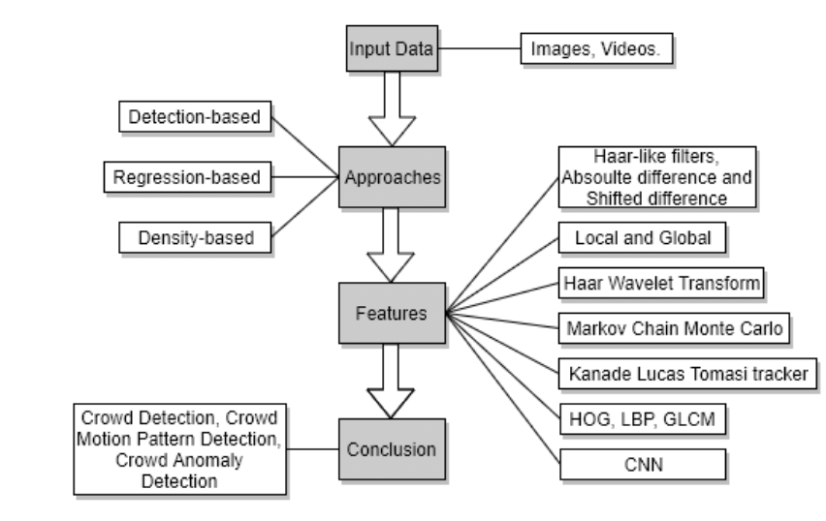
Advantages
• Improved accuracy in high-density crowds (up to 94% mAP).
• Real-time processing with attention mechanisms.
• Robust to occlusions and varying densities.
Disadvantages
• Higher computational requirements than basic YOLO.
• Requires large annotated datasets for training.
• Potential privacy concerns with surveillance applications.
Experimental Results:

Graphs:
Performance Metrics vs Epochs

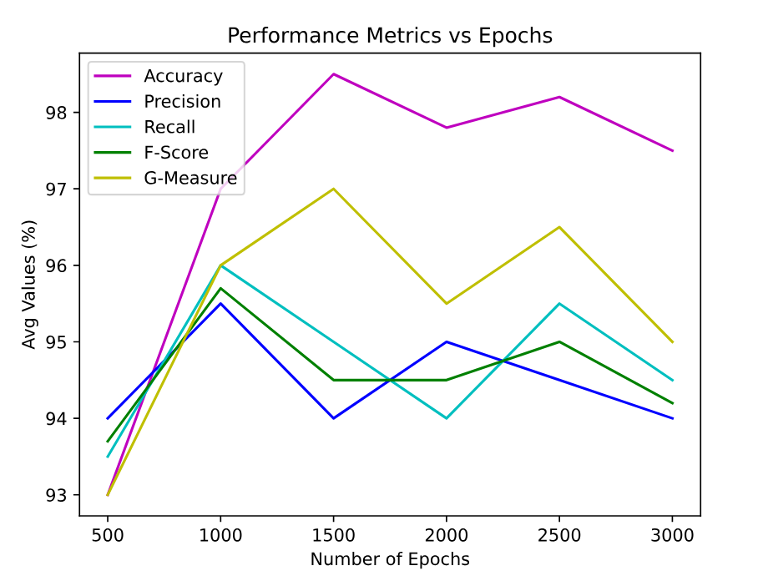

mAP Comparison:
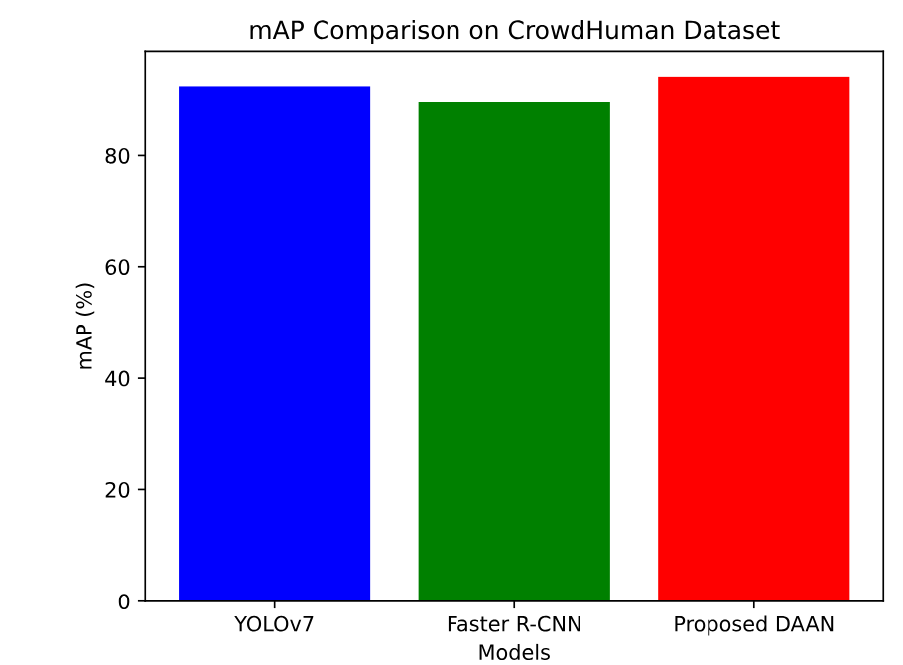
Pictures:
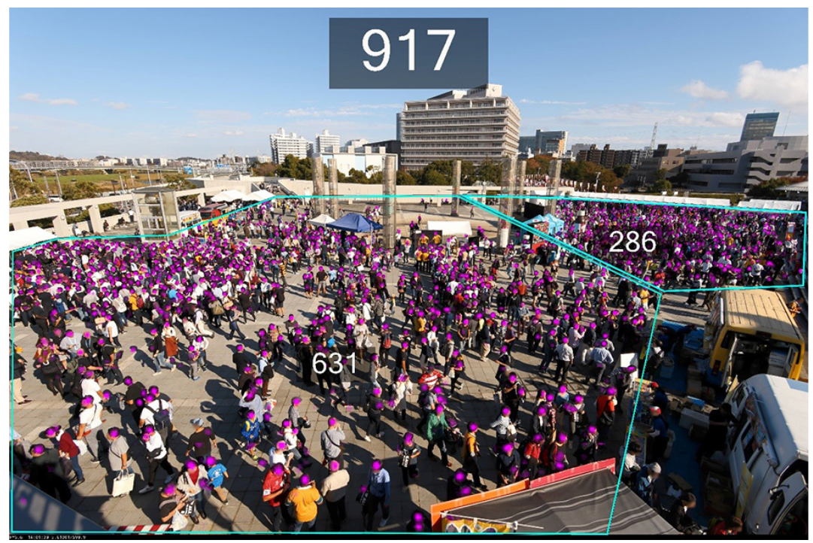
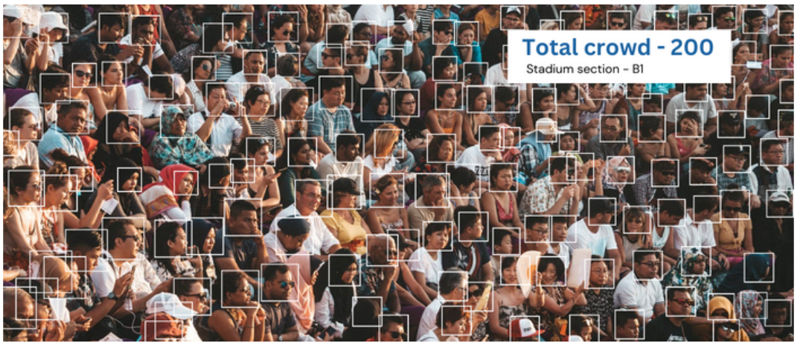

Future Scope
Future research should focus on lightweight models for edge deployment, robustness to
extreme densities, ethical frameworks for privacy, and integration of multimodal data like
thermal imaging.
Conclusions
Deep learning has transformed human image classification and detection in mass crowds, with
frameworks like YOLO and our proposed DAAN leading the way. Despite advancements,
challenges remain, and continued research will enhance the field’s impact.
References
[1] “Deep Learning Approaches for Crowd Density Estimation: A Review,”in Proc. IEEE Conf., 2024.
[2] “Deep Learning-Based Object Detection System for Crowd Monitoring in High-Security Areas,” in Proc. IEEE Conf., 2024.
[3] “Crowd Detection and Analysis for Surveillance Videos using Deep Learning,” in Proc. IEEE Conf., 2021
[4] “Integrating Explainable Artificial Intelligence With Advanced Deep Learning Model for Crowd Density Estimation in Real-World Surveillance Sys-
tems,” IEEE J. Mag., 2024
[5] “Crowd Counting in High Dense Images using Deep Convolutional Neural Network,” in Proc. IEEE Conf., 2021. [Online]. Available: bluehttps://
ieeexplore.ieee.org/document/9663716/
[6] “Context Aware Crowd Tracking and Anomaly Detection via Deep Learning and Social Force Model,” IEEE J. Mag., 2023.
[7] “Dense Crowds Detection and Surveillance with Drones using Density
Maps,” in Proc. IEEE Conf., 2020. [Online]. Available: bluehttps://ieeexplore.ieee.org/document/9213886/
[8] “Crowd Scene Analysis Using Deep Learning Network,” in Proc. IEEE
Conf., 2018.
[9] “Crowd Violence Detection in Videos Using Deep Learning Architecture,”
in Proc. IEEE Conf., 2022
ieee.org/document/9972624/
[10] “Pedestrian Tracking Algorithm for Dense Crowd based on Deep Learning,”
in Proc. IEEE Conf., 2020.
[11] S. Aich, S. Madan, and S. S. S. Teja, “Deep Learning-Based Crowd Scene
Analysis Survey,” J. Imaging, vol. 7, no. 95, 2020.
12] S. K. Kumaran, M. K. Jeyakumar, M. Sam, and M. Bansal, “Deep crowd anomaly detection: state-of-the-art, challenges, and future research directions,” Artif. Intell. Rev., vol. 57, 2024.

